**The National Institute of Engineering**

(An Autonomous Institution under Visvesvaraya Technological University, Belagavi)

Manandawadi Road, Mysuru – 570008

**AICTE Activity on:**

# “CSR ACTIVITY WITH AJITHA NELE”

**Submitted by:**

**RAVI N - 4NI19EE082**

**Under the Guidance of:**

ASHWINI G

Coordinator, Assistant Professor,

Electrical & Electronics. Department

## DEPARTMENT OF E&E ENGINEERING

The National Institute of Engineering

Manandawadi Road, Mysuru – 570008

**PROOF LETTER**

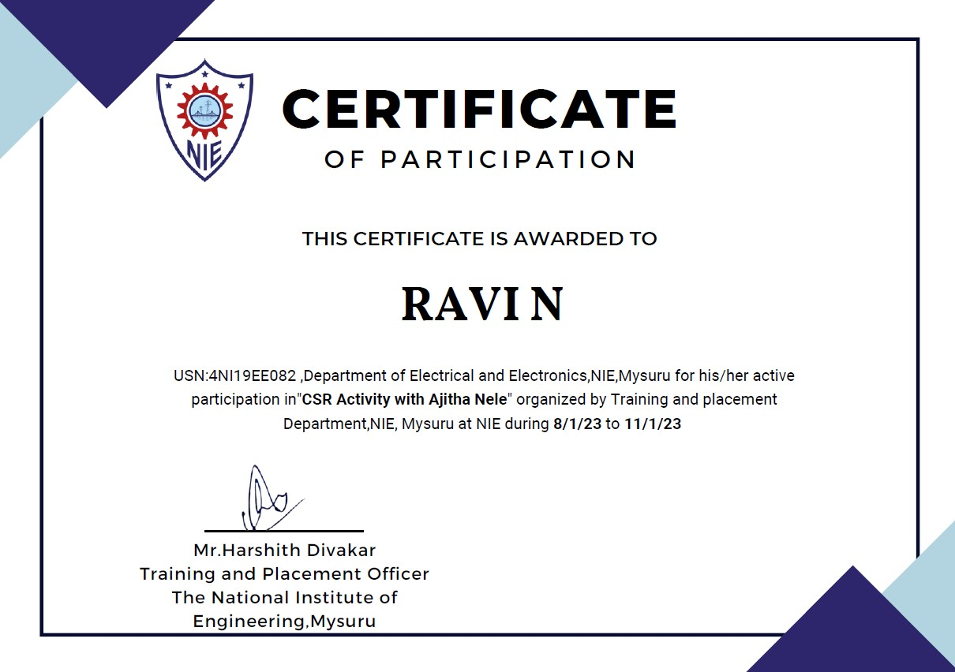

**Acknowledgement**

We would like to thank our guide Ms. Ashwini G for encouragement in our activity, whose cooperation and guidance helped us throughout.

We would also like to extend our thanks to Mr. Harshith Diwakar sir (TPO, NIE, Mysore) for creating this initiation of CSR activity. We would also like to thank chief of Ajitha Nele, Mysore for giving this opportunity of interaction with orphan kids.

**Abstract**

Corporate social responsibility (also known as CSR) is a term used to describe a company’s efforts to improve society in some way. These efforts can range from donating money to non-profits to implementing environmentally friendly policies in the workplace.

CSR helps encourage companies to get involved and support a wide range of non-profit causes. For those charitable organizations, taking a strategic approach to leveraging social responsibility opportunities can help drive corporate giving revenue, employee volunteerism, and more.

The purpose of corporate social responsibility is to give back to the community, take part in philanthropic causes, and provide positive social value. Businesses are increasingly turning to CSR to make a difference and build a positive brand around their company. And because social responsibility is not a mandated practice, it can function as a powerful differentiator for companies that partake.

**Brief Information of the activity**

The AICTE activity points refer to the points that are awarded by AICTE to every engineering student for completing activities prescribed by it.

As a part of this, we undertook and successfully completed an activity for the prescribed duration of Eighty hours. The activity that we undertook was to “CSR Activity for orphanage students” the bringing value to the community and generating a positive impact. We conducted this activity from 8/01/2023 to 11/01/2023. This activity was conducted as a team which consisted of ten members.

**Initiation of Activity**

Our activity began with planning for the activities that need to be conducted for the orphan kids and to engage them physically, intellectually.

Several activities were planned in order to keep them entertained at the same time enlighten them regarding the importance of education.

There were 40 orphan kids of all the age groups who were extremely talented and well disciplined.

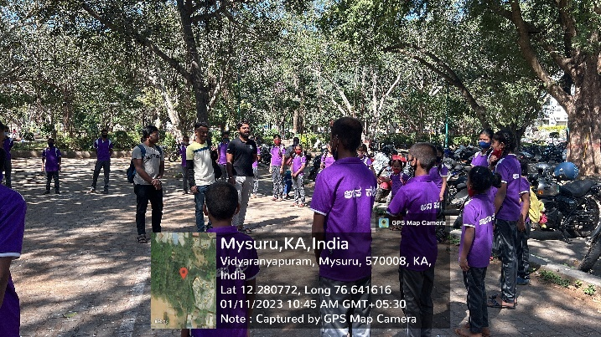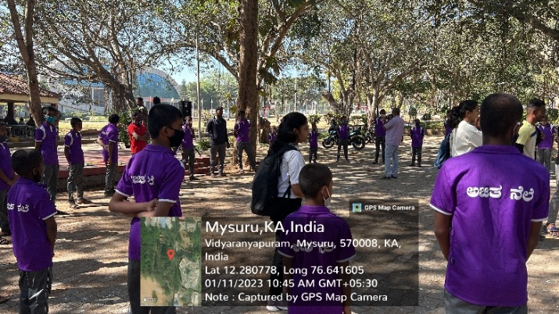

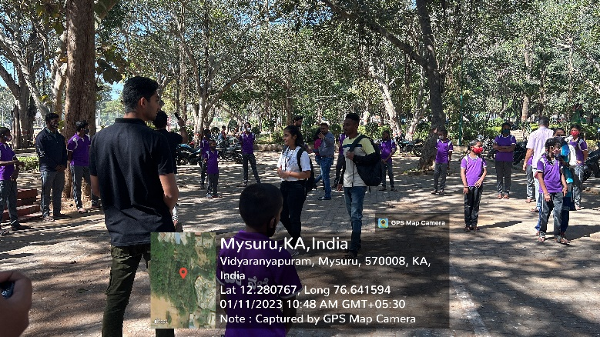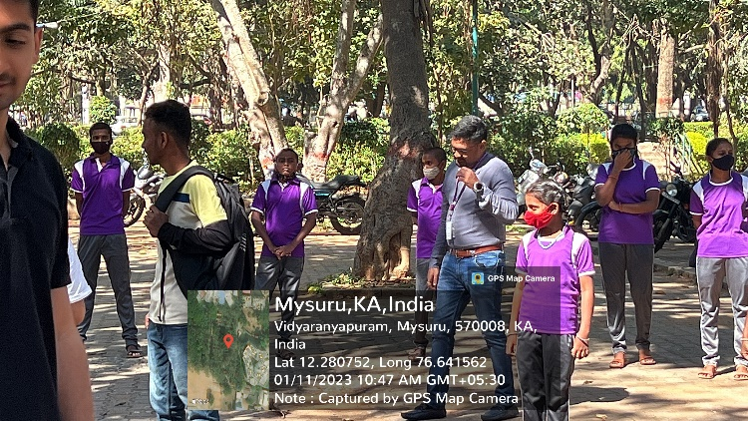

**Interaction with students**

The activity began by 10am and it started with interaction of the students and knowing their interest in field of education as well as co-curricular activity.

The kids were very much talented, they interacted with us so well. They also gave a dance and music performance.

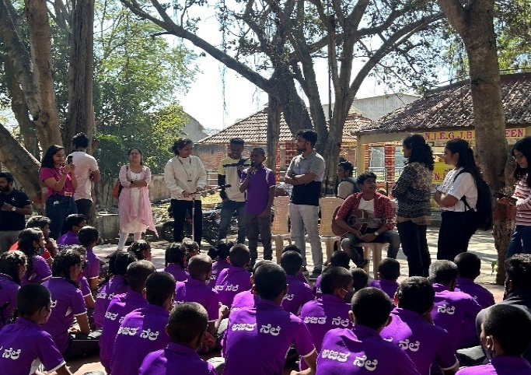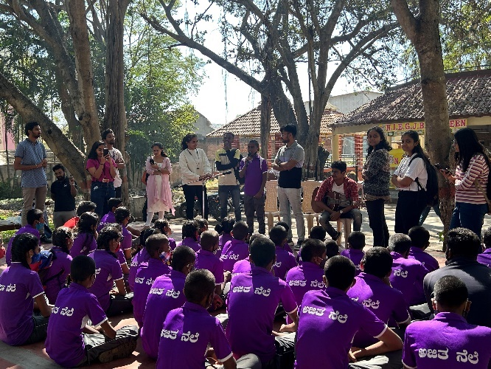

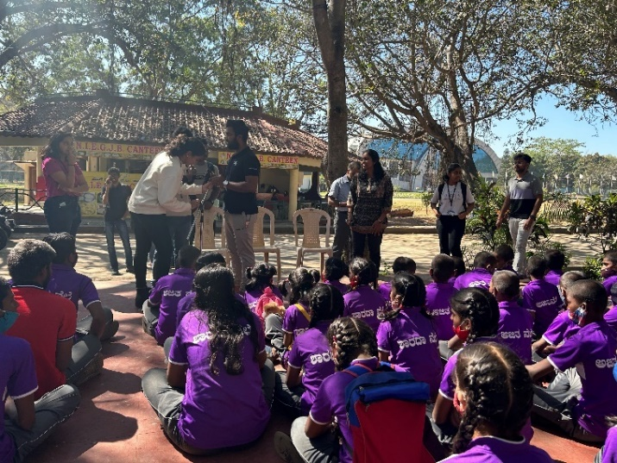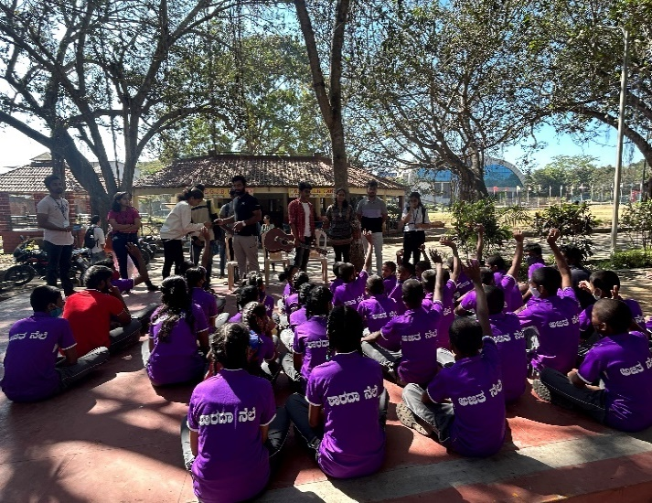

**Technical Guidance**

The students were taught with many technical software used in day-to-day life.

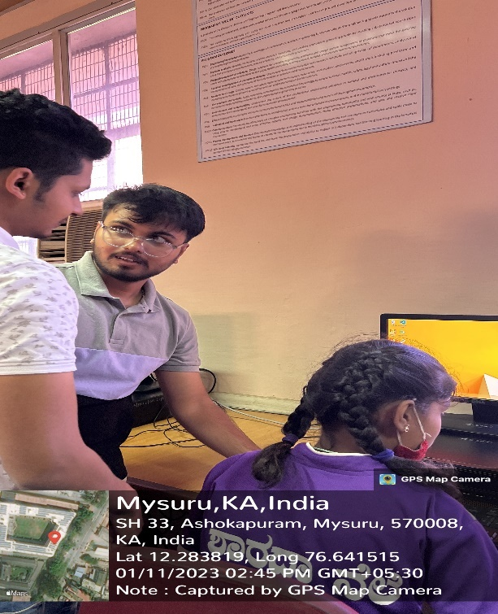They were taught with PowerPoint, word, usage of google etc.

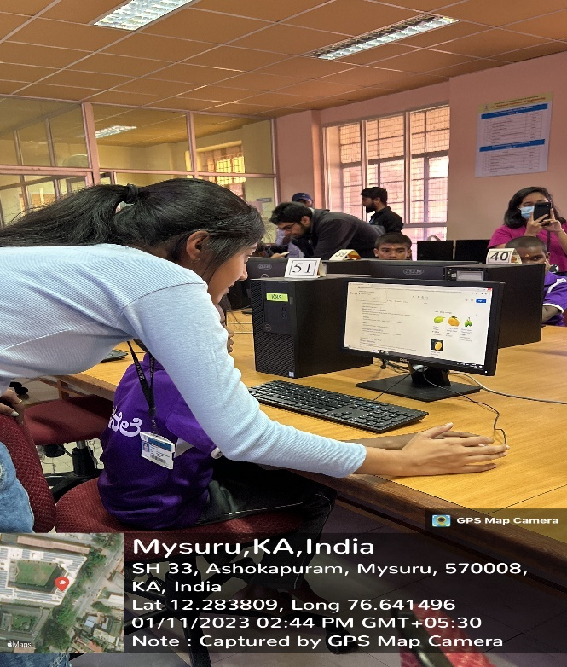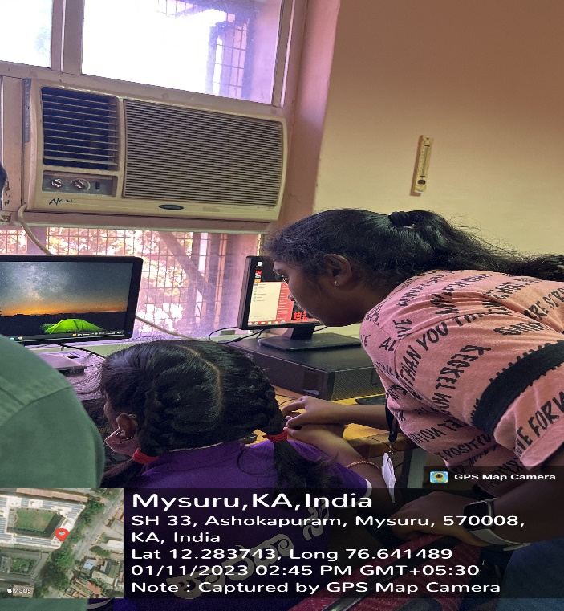

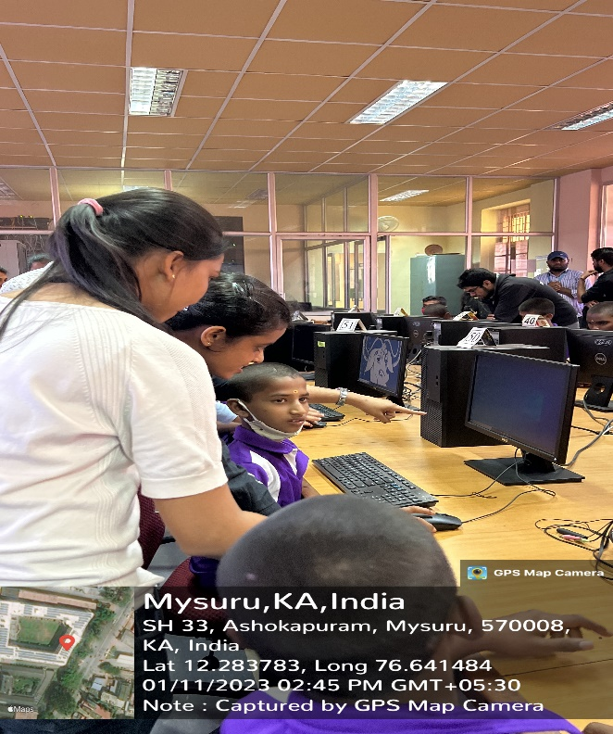

**Career guidance**

Students of class 8 to 10, Setting the basics right solves a lot of confusions that might arise later. Whether it is choosing the correct stream to the correct board, and mapping career goals, a right start at the right time makes all the difference.

Briefing about the importance of education in one’s life, we motivated students about the values, opportunities that one gets through education.

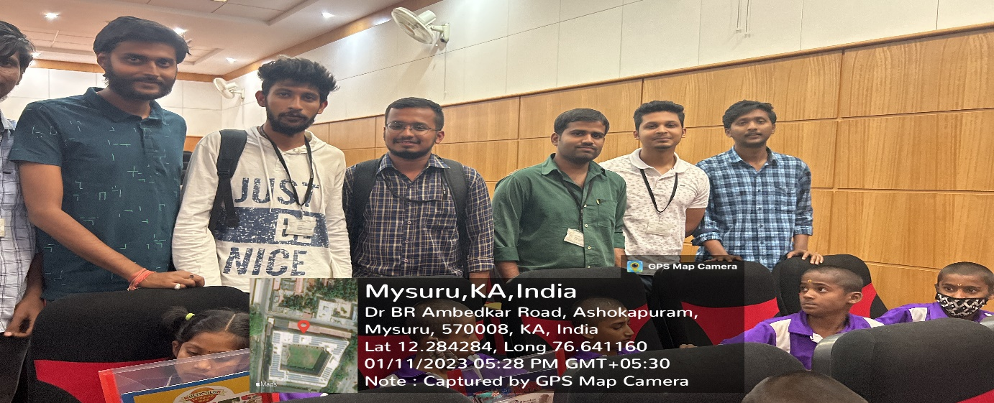

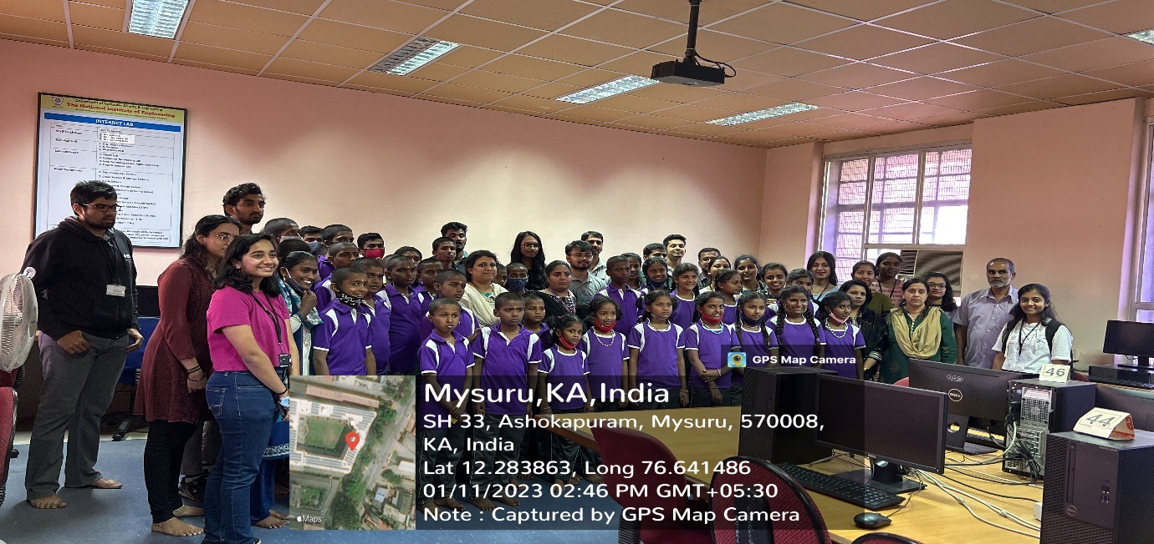

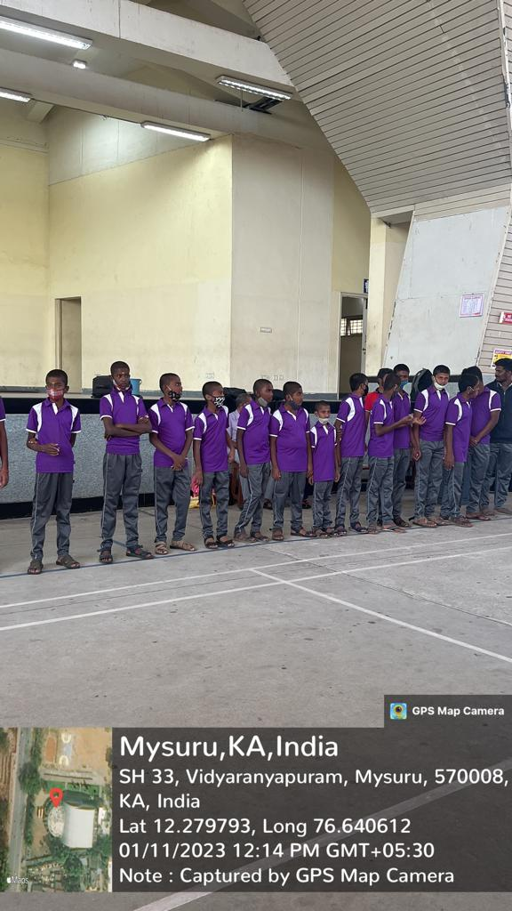They were also engaged with lot of physical activities such as table tennis, basketball, throw ball etc

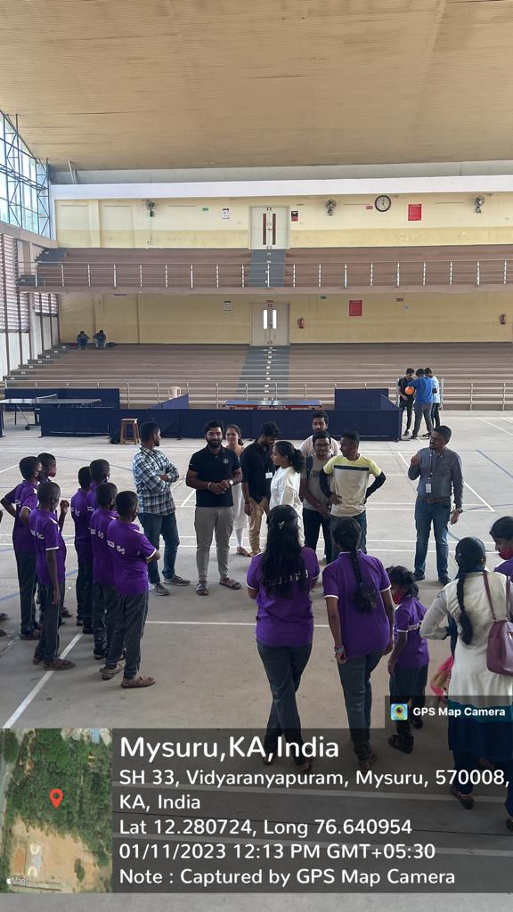

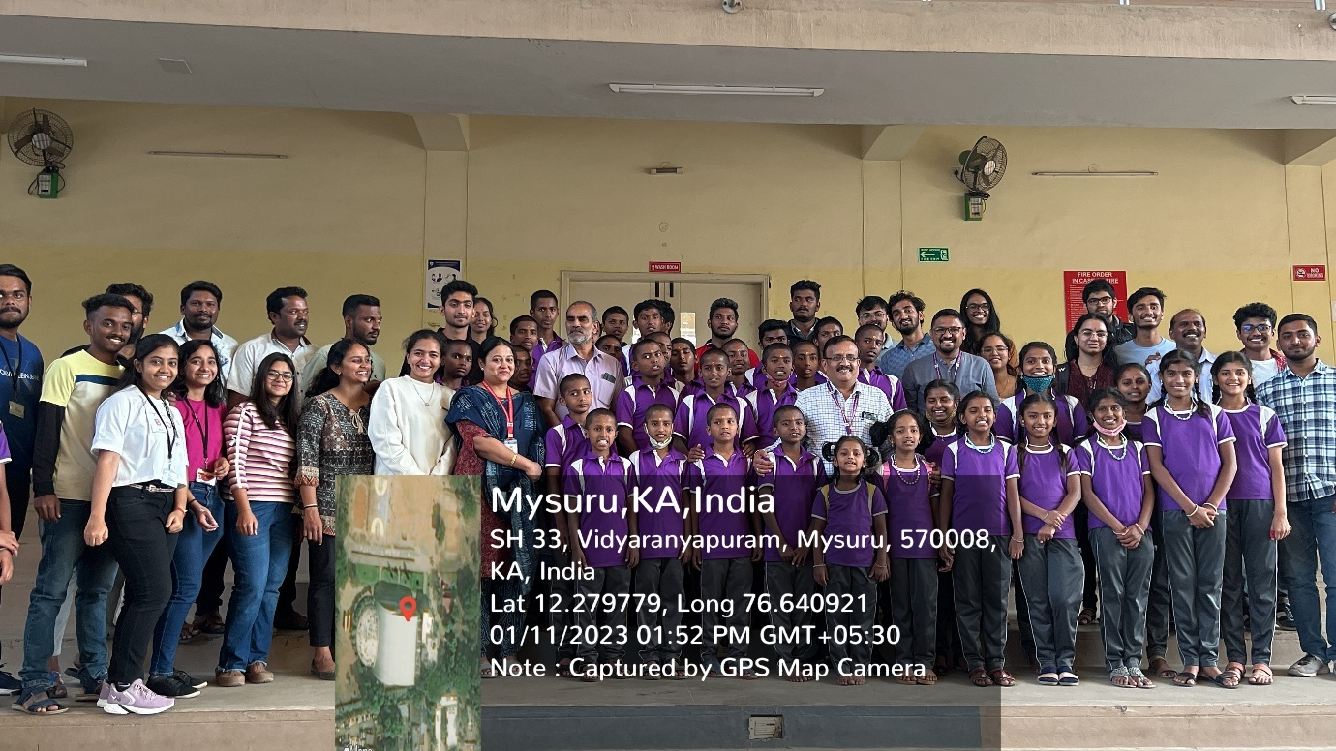

At the end of the session, the kids were provided with stationaries by the organisation.

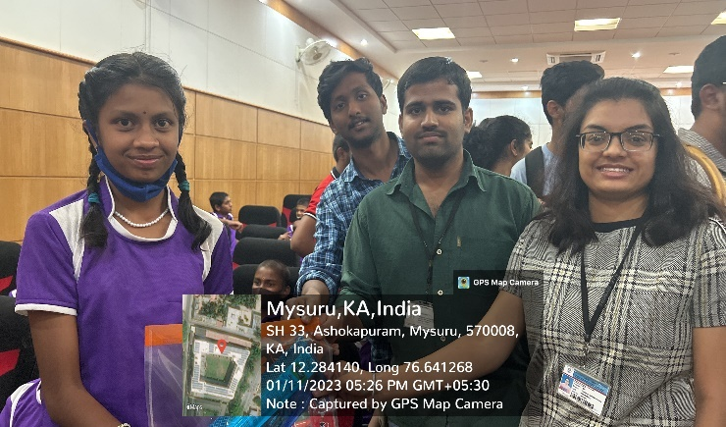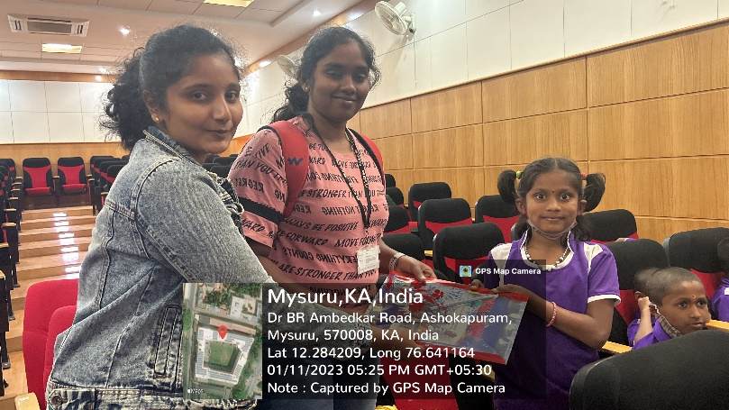

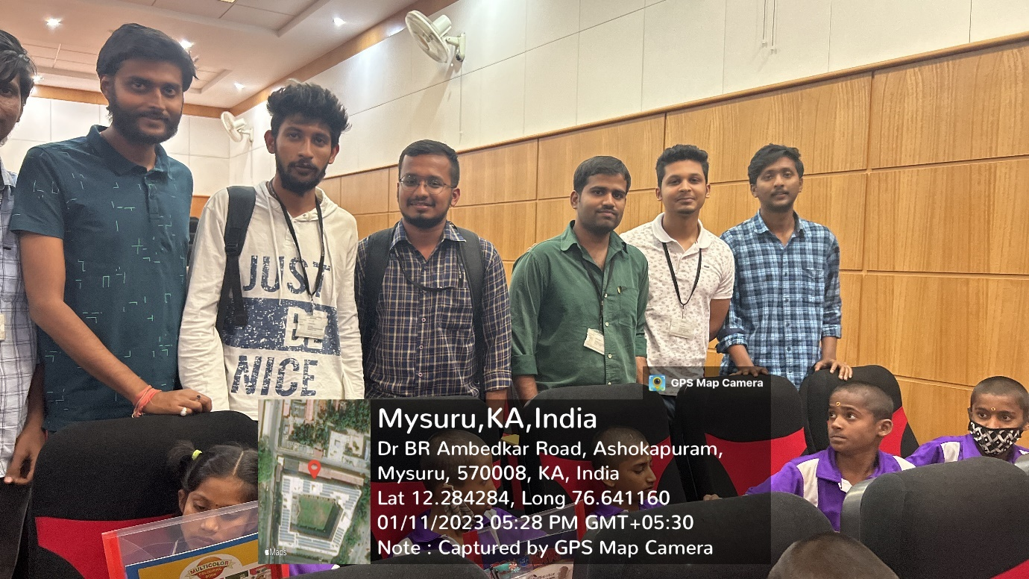

**Conclusion**

To teach is to learn as they say, during this activity not only did we realize the difficulties of being a teacher but also discern the significance of education. Though the kids are orphans the discipline and the interest that they have was really impressive.

The people who are involved in sculpting these students has really done an great job, they have given a good responsible citizens for our future nation.

We have experienced culture change, adjustments, and new students to handle. The attitudes of the students were also different, they were interested in each and every thing that we were teaching them and also they also had eagerness of learning new things. We were able to face the reality of being a public teacher. We genuinely appreciate all the people we have encountered, especially the students.

We will never forget our experiences. We have learned a lot and we are craving for more wisdom to be bestowed upon us.

